Mental Health Scale-Up Fund – Fund criteria

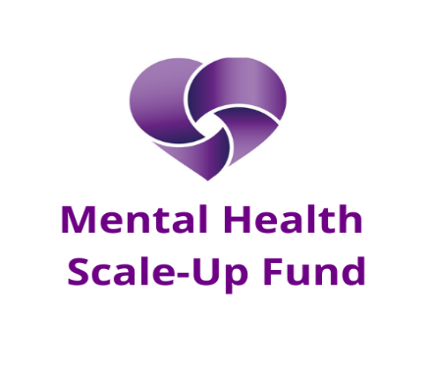

Purpose
At the Community Foundation for Surrey, we are seeking to produce a step change improvement to the support that is available in Surrey for young people’s mental health. For us ‘young people’ means from birth to 30 years of age. Our Mental Health Scale-Up Fund aims to support what is clearly working – and make it available to more people.
We particularly want to fund projects which demonstrate clear, measurable impact in young people and have the ability to scale-up to reach:
- More beneficiaries, or,
- Beneficiaries in cohorts that are experiencing particular challenges in mental health, or,
- Beneficiaries that struggle to access support, or,
- Beneficiaries across a wider geographic area.

Eligibility
- The Community Foundation for Surrey Eligibility criteria apply.
- For this fund only organisations which have previously been funded by the Community Foundation since 2018 may apply.

What we will fund
- Projects with a demonstrable track record of supporting the mental health of young people up to 30 years old.
- Expansion of existing services to under-provided geographical areas.
- Replication of exiting services to reach new cohorts of young people currently not adequately supported.
- We would be delighted to support projects that involve collaboration between multiple organisations
- We will fund projects that scale-up over an initial 5-year period, recognising that organisations may need to carry out work to be ‘scale-up ready’ which may involve building new partnerships or developing new process and procedure.
- We will be happy to fund ‘gradual’ scale-up over a multi-year period – we want to support organisations/programmes to grow well.
- This is a learning programme – we will support projects to evaluate their impact and to share their best practice with others in the field.
- As part of our learning, we will be flexible with our funding – we want to keep in regular contact with our funding recipients throughout the initial 5 years, and will be flexible and responsive with the funding – learning from what is working and what is not going well as we go.

What this fund will not support (because there are other CFS funds that will fund the following – and you should apply through our regular Expression of Interest route)
- Pilot projects.
- Start ups.
- ‘Innovation’ work that is trialling new interventions that have not been tested before.

Size of grants
- We will offer funding of up to £50,000 per annum for up to 5 years in the first instance.
- Smaller applications are welcome.
- ‘Staged’ applications are welcome – for example you may need to invest larger amounts in the first year, in order to be able to grow at a steady rate, or you may need to grow slowly at first in order for you to be able to develop your capability. A ‘smooth’ grant of £50,000 per annum for 5 years may not be what is required to ensure successful scale-up.
How to Apply to the Mental Health Scale-Up Fund
Start an application via the Community Foundation for Surrey Expression of Interest process. Eligible projects will be invited to make a full application. You should particularly cover:
- How do you know what you are doing to support young people’s mental health is working.
- How would this funding enable you to scale-up in a sustainable, manageable way over the next 5 years.

Application guidance
Budget - Your budget should include:
- Full cost recovery.
- Costs for planning and implementing an expansion of services.
- Costs of evaluation and dissemination of learning.
- The fund does not support capital projects but small capital items such as laptops would be eligible.
When funding individual grant applications we will consider the organisations’ sustainability planning. We will award grants for 5 years in the first instance (subject to review) and want to ensure that when our grant stops that we have also helped organisations to attain a more sustainable programme that will continue in the future.

Alternative funds
Organisations seeking funds for pilot projects, or innovative new approaches should apply through our usual quarterly deadlines under either the Young People theme or Wellbeing and Health theme - read more
Organisations who are doing great work to support young people’s mental health, but do not feel ready to be able to scale-up, may like to consider the opportunity to make changes to their business to become ‘scale-up ready’ and may wish to apply to our Strategic Transformation Fund before making an application to this fund.

